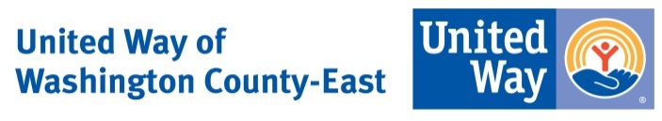

2018 Kay Clint Application Checklist

Each organization must fill out the “Program Application” for the program you are applying for a grant
While filling out the Program Applications for your organization, do not change or modify font sizes and formats

Items to Submit to UWWCE:

Return 2 hard copies of the completed Kay Clint Program application
IRS 501(c)(3) tax exemption letter
Most recent audited financial statements and IRS Form 990.
One year program budget, listing all revenue sources and projected expenses
List of Board of Directors and their affiliations and a brief description of key staff members
Annual report, if available (1 copy)
E-mail a PDF of each of the above-mentioned items to lois@uwwce.org and Jessica.ryan@uwwce.org
** A grant impact report is due to the UWWCE (email lois@uwwce.org and Jessica.ryan@uwwce.org
6 months after receiving funding

United Way of Washington County-East
Kay Clint Fund for emerging needs
Telephone: (651) 439-3838 Email: lois@uwwce.org and Jessica.ryan@uwwce.org
Street Address: 1825 Curve Crest Blvd., Stillwater, MN 55082
Mailing Address: P.O. Box 305, Stillwater, MN 55082

